**Day 3 – E-Mail Service**

1. Research the following internet protocols related to e-mail services.
   1. SMTP Protocol

-Allows your PC to send mail

* 1. POP3 Protocol

-Allows your PC to read mail

* 1. IMAP Protocol

-Allows your PC to read mail

* 1. Web Mail  
     - All mail stays on the server

- Server provides a dynamic   
web site that you access  
through a web browser

1. Use the following resource as a starting point:  
   <https://askleo.com/what_is_pop_or_pop3_or_a_pop_account_and_what_about_smtp/>
2. Complete the following Venn Diagram to summarize your research.

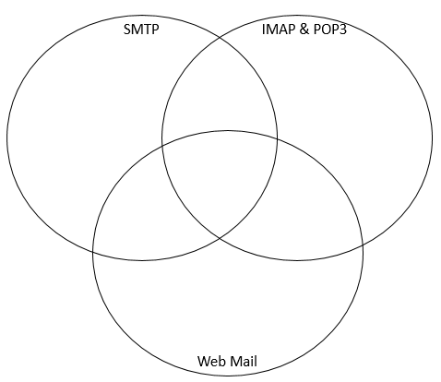

* All mail stays on the server
* A dynamic web site, you can access
* Allows PC to read mail
* Allows PC to send mail